1. Top-Level Components
- Client Applications (parent) – Encloses Web Client + Mobile Client (unified UI that supports both student and company roles) – Admin Team
- Web Client – Web-based user interface – Team 3 (Spencer Beals)
- Mobile Client – Mobile application user interface – Team 3 (Spencer Beals)
- API Gateway / Orchestrator – Central entry point for all client-to-service and service-to-service communication (cross-cutting) – Team 6 (Robert Anderson)
- Authentication Service – Handles login, registration, roles, sessions – Team 4 (Kimberly Uresti)
- Profile Management Service – Company profiles (locations, data, following students) + Student profiles (accolades, skills, GPA, etc.) – Team 4 (Kimberly Uresti)
- Resume Service – Resume forms, submissions, storage, access by companies – Team 7 (Marco Quintero)
- Job Posting Service – Create/edit/delete job postings, required skills, additional job info – Team 2 (Savannah Harvey)
- Search Service – Company candidate search + student job/company search (with filters, autocomplete, wildcards) – Team 2 (Savannah Harvey)
- Communication Services – Notifications (in-app + push) + News Feed (posts, company/student updates, university stats) – Team 6 (Robert Anderson)
- Recommendation Service – Job and candidate recommendations based on profiles, resumes, and job postings – Team 7 (Marco Quintero)
- External Services – Third-party integrations (USPS address validation, autocomplete APIs, push notifications, etc.) – Team 5 (Adam Sheridan)
- Analytics Service – Reporting, usage insights, and analytics on job postings, profiles, searches, and notifications – Team 5 (Adam Sheridan)
- Data Storage Layer (parent) – Encloses Database and File/Blob Storage – Admin Team
- Database – Persistent structured data storage for all system data – Team 1 (Danny Capps)
- File / Blob Storage – Storage of uploaded resumes, profile images, attachments, and other binary files – Team 1 (Danny Capps)

2. Connections (Interfaces)
- Clients require the REST/HTTP API Port from the API Gateway (this is the formal, well-defined entry point for all client communication)
- Services provide and require specific interfaces to each other (e.g., Profile Management Service provides “Profile Data” interface to Search Service and Communication Services)
- All services require the SQL / Data Access Port from the Data Storage Layer (this is the single formal port through which every service accesses persistent data)
- Communication Services may have additional external ports for push notification services (e.g., Firebase / Apple Push Notification Service) if implemented later

Sketch Diagram With Assignments
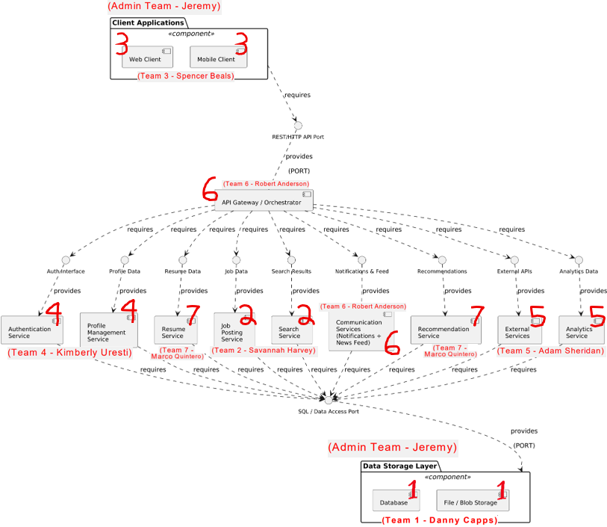

Milestone 1 Team Assignments
- Admin Team (Jeremy) —> Client Applications
- Team 3 (Spencer Beals) —> Web Client
- Team 3 (Spencer Beals) —> Mobile Client
- Team 6 (Robert Anderson) —> API Gateway / Orchestrator
- Team 4 (Kimberly Uresti) —> Authentication Service
- Team 4 (Kimberly Uresti) —> Profile Management Service
- Team 7 (Marco Quintero) —> Resume Service
- Team 2 (Savannah Harvey) —> Job Posting Service
- Team 2 (Savannah Harvey) —> Search Service
- Team 6 (Robert Anderson) —> Com Services (Notifications + News Feed)
- Team 7 (Marco Quintero) —> Recommendation Service
- Team 5 (Adam Sheridan) —> External Services
- Team 5 (Adam Sheridan) —> Analytics Service
- Admin Team (Jeremy) —> Data Storage Layer
- Team 1 (Danny Capps) —> Database
- Team 1 (Danny Capps) —> File / Blob Storage

3. How Components Tie into Requirement

Component | SRS Sections / Requirements It Directly Supports
Client Applications  (Admin Team - Jeremy)  Parent Component | • 1.2 Application Scope (web and mobile interfaces that share the same features)  • Overall client-side architecture, shared UI patterns, role-based views, and coordination between web and mobile clients
Web Client  (Team 3 – Spencer Beals)  Parent Component | • Primary web-based user interface (browser UI)  • Implements all web UI elements for Company and Student features (sections 2.x and 3.x)  • Profile pages, search bar, forms, news feed display, notifications display, resume form, job browsing, etc. (1.2.1)
Mobile Client  (Team 3 – Spencer Beals)  Parent Component | • Mobile application user interface  • Implements the same features and characteristics as the Web Client (per SRS 1.2.1)  • Mobile-optimized UI for all features in sections 2.x and 3.x (profiles, search, news feed, notifications, resume form, job browsing, etc.)
API Gateway / Orchestrator  (Team 6 – Robert Anderson)  1 Component | • Cross-cutting orchestration for all client–service communication (implicit in 1.2 and all functional requirements in 2.x / 3.x)
Authentication Service  (Team 4 – Kimberly Uresti)  1 Component | • Foundational requirement for all logged-in features (profiles, following, notifications, job postings, resume access, etc.)  • Required for every section under 2.x and 3.x
Profile Management Service  (Team 4 – Kimberly Uresti)  1 Component | • 2.1 Company Profile Page (2.1.1–2.1.3.10)  • 3.1 Student User Profile (3.1.1–3.1.3.3)
Resume Service  (Team 7 – Marco Quintero)  1 Component | • 3.5 Resume (3.5.1–3.5.5.2)  • Referenced in 2.1.2, 2.2.5, 2.3.3, 2.3.5, 2.5.6, 3.1.3.1–3.1.3.3
Job Posting Service  (Team 2 – Savannah Harvey)  1 Component | • 2.5 Job Postings (2.5.1–2.5.7)  • Referenced in 3.3.1, 3.4.1, 2.2.5
Search Service  (Team 2 – Savannah Harvey)  1 Component | • 2.3 Search Features (2.3.1–2.3.8)  • 3.3 Search Features (3.3.1–3.3.2)
Communication Services (Notifications + News Feed)  (Team 6 – Robert Anderson)  1 Component | • 2.2 Notifications (2.2.1–2.2.5)  • 2.4 News Feed (2.4.1–2.4.6)  • 3.2 Notifications (3.2.1–3.2.7)  • 3.4 News Feed (3.4.1–3.4.2)
Recommendation Service  (Team 7 – Marco Quintero)  1 Component | • Job and candidate recommendations based on profiles, resumes, and job postings  • Supports 2.3 Search Features, 2.5 Job Postings, 3.3 Search Features, and 3.1/3.5 profile/resume data
External Services  (Team 5 – Adam Sheridan)  1 Component | • External integrations (USPS address validation in 2.1.3.9, autocomplete API in 2.3.6, push notification services in 2.2, etc.)  • Any third-party APIs referenced throughout the SRS
Analytics Service  (Team 5 – Adam Sheridan)  1 Component | • Provides reporting and analytics on job posting performance (views, applications, 2.5), candidate search effectiveness (filters, results, 2.3), profile and resume engagement (2.1, 3.1, 3.5), and notification / news feed activity (2.2, 2.4, 3.2, 3.4)  • Monitors key performance metrics (e.g., search results returned within 3 seconds per 2.3.5)  • Supports data-driven platform improvements, usage insights, and overall system monitoring
Data Storage Layer  (Admin Team - Jeremy)  Parent Component | • Provides the single unified SQL / Data Access Port used by every service in the system  • Acts as the central enclosing component that coordinates Database and File/Blob Storage  • Manages system-wide data concerns (transactions, consistency, backups, scalability, reliability)  • 4. Hardware requirements (implicit backend storage, servers, infrastructure)
Database  (Team 1 – Danny Capps)  Child Component | • All persistent data storage for profiles, resumes, job postings, notifications, news feed, authentication, etc.  • Referenced in every “Data X.X.X” entry throughout the SRS
File / Blob Storage  (Team 1 – Danny Capps)  Child Component | • Storage of uploaded resumes, profile images, attachments, and other binary files  • Supports 3.5 Resume submission and any file-related requirements

4. Work Division Plan (Parallel, Independent Work + Easy Integration)
Each of the seven teams is responsible for two major components, including its internal sub-components, allowing work to be completed in parallel with minimal overlap. The Admin Team is responsible for the cross-cutting components as well as final system integration, ensuring that all independently developed pieces align and function cohesively within the overall architecture.

Team | Assigned Component(s) | Key SRS Features Covered | Deliverables from Team
Team 1 (Danny Capps) | - Database  - File / Blob Storage | All persistent data storage, resumes, profiles, job postings, notifications, news feed, file uploads | 1. Top-level component boxes for Database and File / Blob Storage (to be integrated into the master diagram)  2. Detailed sub-diagram(s) showing the internal structure of Database and File / Blob Storage + data access interfaces
Team 2 (Savannah Harvey) | - Job Posting Service  - Search Service | 2.5 Job Postings, 2.3 & 3.3 Search Features, filters, autocomplete | 1. Top-level component boxes for Job Posting Service and Search Service (to be integrated into the master diagram)  2. Detailed sub-diagram(s) showing the internal structure of each component + interfaces
Team 3 (Spencer Beals) | - Web Client  - Mobile Client | 1.2 Application Scope (web + mobile UI), all user-facing features (profiles, search, forms, news feed, notifications, resume, job browsing) | 1. Top-level component boxes for Web Client and Mobile Client (to be integrated into the master diagram)  2. Detailed sub-diagram(s) showing the internal UI modules and required interfaces to API Gateway for each client
Team 4 (Kimberly Uresti) | - Authentication Service  - Profile Management Service | Authentication (all logged-in features), 2.1 Company Profiles, 3.1 Student Profiles | 1. Top-level component boxes for Authentication Service and Profile Management Service (to be integrated into the master diagram)  2. Detailed sub-diagram(s) showing internal structure + provided/required auth & profile interfaces
Team 5 (Adam Sheridan) | - External Services  - Analytics Service | External integrations (USPS, autocomplete, push notifications), reporting & analytics | 1. Top-level component boxes for External Services and Analytics Service (to be integrated into the master diagram)  2. Detailed sub-diagram(s) showing internal structure + external & analytics interfaces
Team 6 (Robert Anderson) | - API Gateway / Orchestrator  - Communication Services (Notifications + News Feed) | All client–service orchestration, 2.2 & 3.2 Notifications, 2.4 & 3.4 News Feed | 1. Top-level component boxes for API Gateway / Orchestrator and Communication Services (to be integrated into the master diagram)  2. Detailed sub-diagram(s) showing internal structure + orchestration & notifications/feed interfaces
Team 7 (Marco Quintero) | - Resume Service  - Recommendation Service | 3.5 Resume, job/candidate recommendations based on profiles/resumes/job postings | 1. Top-level component boxes for Resume Service and Recommendation Service (to be integrated into the master diagram)  2. Detailed sub-diagram(s) showing internal structure + resume & recommendation interfaces
Admin Team (Jeremy Suchanski) | - Client Applications  - Data Storage Layer  - Master Diagram | Overall system architecture, unified SQL/Data Access Port, interface consistency, integration of all sub-diagrams | Master top-level diagram, interface glossary, final integration & consistency rules

Milestone 1 Deliverables

1. Top-Level Component Representation
Create the clean outer box for each of your assigned component(s) with the correct name, interfaces, and ports exactly as outlined in the master sketch.
This is what will go into the single final master diagram.

2. Detailed Sub-Diagram
Create one or more detailed sub-diagrams that show what is inside your assigned component(s).
This follows the guidance in Chapter 4.0 (p. 882): that states when a component becomes complex, you break it into sub-diagrams while keeping the same interface names on the boundary.

Important Notes
- The Chief Editor will assemble the single master top-level diagram from everyone’s top-level component boxes.
- You only need to make sure your component’s name and interfaces match the master diagram exactly.
- The teams each have two components — you can combine them into one sub-diagram if it makes sense, or do two separate ones. Either is fine.
- Submit both the top-level component box(es) and the detailed sub-diagram(s) to Nathan (Chief Editor) before the deadline.

